**Summary Statistics for Sex and Highest Degree**

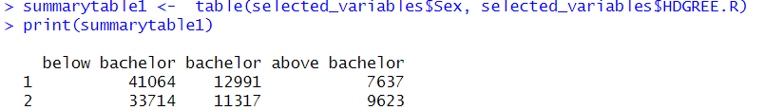

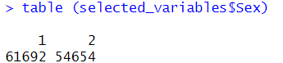

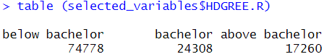

* In our sample, we have 61692 women and 54654 men, total 116 346 persons.
* 74778 is the number of persons in the educational level ‘below bachelor’ (41064 women and 33714 men).
* 24308 is the number of persons in the educational level ‘bachelor’ (12991 women and 11317 men).
* 17260 is the number of persons in the educational level ‘above bachelor’ (7637 women and 9623 men).

**Summary Statistics for Sex and Highest Degree (Percentage)**

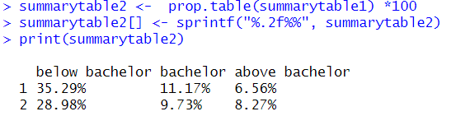

This table shows the **percentage distribution** of men and women across each education level category, based on the absolute values from the previous table.

The percentages represent the proportion of individuals in each combination of gender and education level, relative to the overall total (both men and women combined).

* For women (code 1):
  + **35.29%** of people have an education level below a bachelor's degree,
  + **11.17%** have a bachelor's degree,
  + **6.56%** have an education level higher than a bachelor's degree.
* For men (code 2):
  + **28.98%** of people have an education level below a bachelor's degree,
  + **9.73%** have a bachelor's degree,
  + **8.27%** have an education level higher than a bachelor's degree.

This indicates that, out of all individuals in the sample, a higher percentage of women are concentrated in the education level below a bachelor's degree, while a higher percentage of men are in the category above a bachelor's degree.

**Regression Table**

